BURWASH AND BURWASH WEALD BRANCH
Bexhill & Battle Conservative Association

We cordially invite Members, Friends and their Guests
to join us for a summer lunch in the gardens of

Little Park Hill
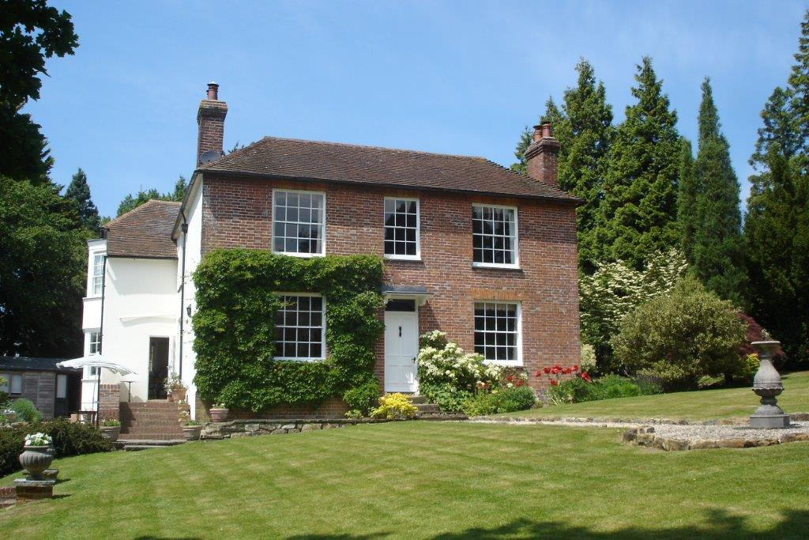

Saturday, 9th July 2016
12:30 for 1.0pm
at Little Park Hill, Willingford Lane, Burwash Weald, TN19 7HR
RSVP
  Free Bar | Tickets: £ 20  Ample Parking  Disabled Access   | Raffle

======================================================================================================================================================
To reserve, please detach, complete and return, or apply by email or telephone.
Name/s:
Post code: Telephone:
I/We request ___ places for the lunch at Little Park Hill and enclose a cheque for £___
Please make cheques payable to Burwash Branch BBCA and return to:
Michael Jameson-Till, Little Park Hill, Burwash Weald, East Sussex, TN19 7HR.
Tel: 01435 882729 Email: michael@majtill.free-online.co.uk

