BEXHILL & BATTLE CONSERVATIVE ASSOCATION
BATTLE BRANCH
invites you and your friends to a
CELEBRITY CHEF DINNER
to be prepared and cooked by
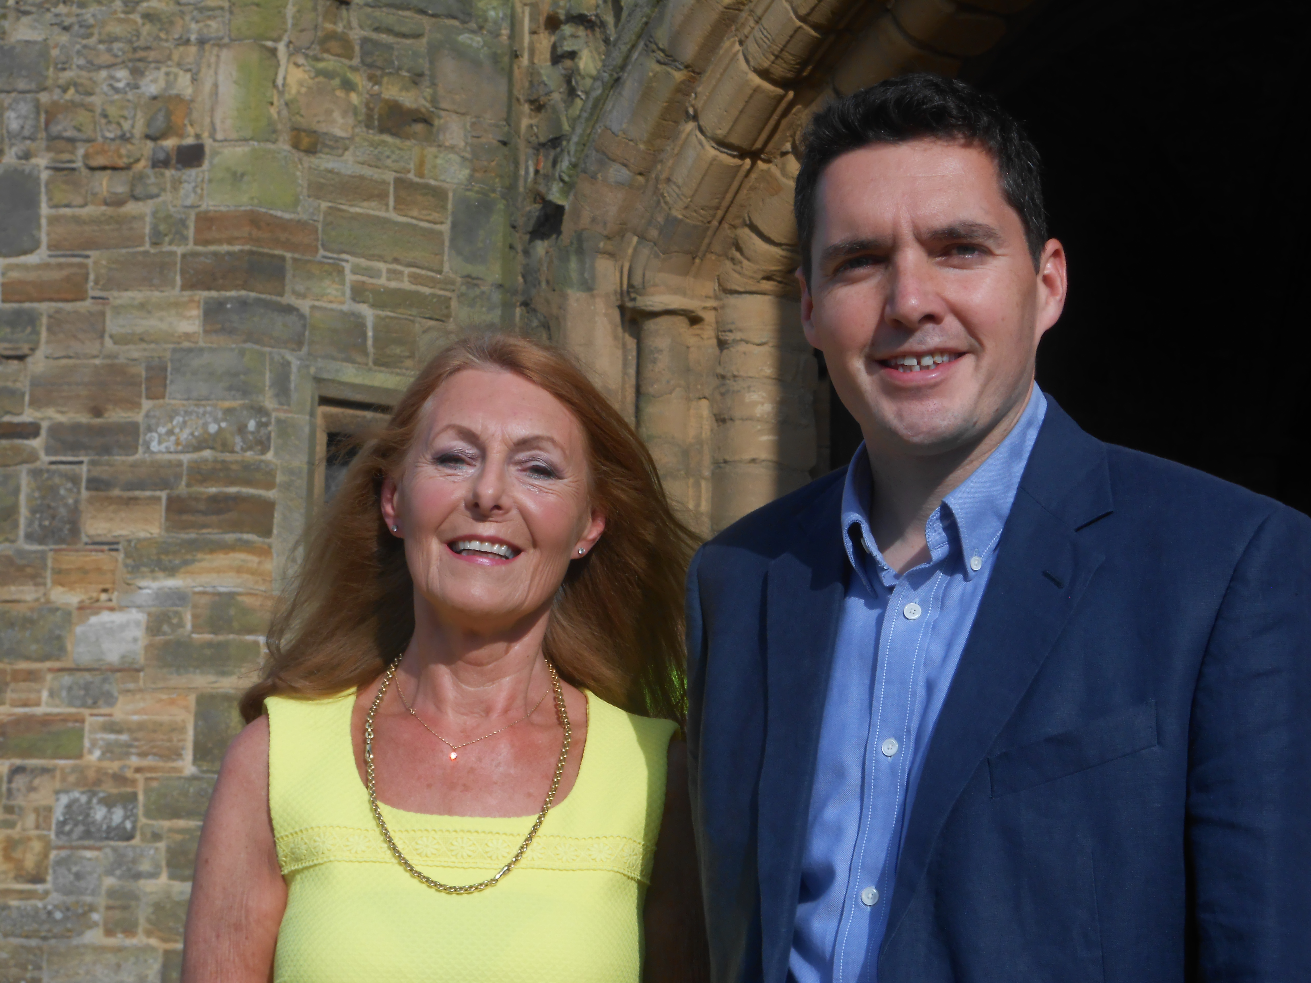

HUW MERRIMAN MP
FRIDAY 10th MARCH
at
BATTLE MEMORIAL HALL
WYNNE ROOM
Fizzy Reception 6.30pm for 7.00pm
Three course dinner
If you and your friends would like to join us for this very special supper, please enclose a cheque for the appropriate amount, made payable to BBCA, with the slip below no later than March 1st to: ….................................................................................................
Hazel Sharman, Heaton Lodge Netherfield Hill, Battle,
TN33 0LE. Tel. 01424 775890 Dress code: Smart casual
Name.........................................................………………………………………………………………
I would like ….....................................Tickets at £25. per head.
Tel No..............................................…………………………………………………………………….
I would like to sit with…………………………………………………………………………………
Any special dietary requirement……………………………………………………………………...

